Overview and Considerations:
The determination of the number of cells is important in monitoring cell lines and setting up experimental conditions. Knowing the number of cells allows the conditions to be kept constant between experimental conditions and allows the accurate elucidation of cellular responses. The simplest method of cell number determination is with the use of a hemocytometer. Note this method is suitable for counting a small number of cells. The hemocytometer involves a microscope slide that will hold a glass cover slip 0.1mm above the counting chamber floor (Fig. 1). The counting chamber is etched and the total surface area is 9mm². Calculation of the cell number is based on counting the number of viable cells within a defined area and incorporating the applied dilution factors. The protocol for cell counting employing a hemocytometer is as follows.

Reagents:
- Hemocytometer
- Trypan Blue
- 0.25% Trypsin-EDTA

Protocol:
- Discard the media and wash the cells with PBS (approx. 10ml for 150mm or 5ml for 100mm plates)
- Add 1X trypsin EDTA to the cell surface making sure that it covers the entire surface and incubate for 30sec-5min at 37°C and 5% CO₂. Example: For a 150mm plate, add 3ml of trypsin EDTA, for a 100mm plate add 1-1.5ml.
- After incubation wash and resuspend the detached cells in 7-10ml of fresh media. Remove the cell suspension and place into a clean tube. The fresh media contains trypsin inhibitors, if trypsin is left too long on the cells they will die. Make a note of the total volume containing media and cells.
- Make sure the cells are resuspended in the media and take a small aliquot (~500 ul) into a clean 1.5 ml tube.
- Take 100 ul of the cell suspension and mix with 100 ul of 0.4% trypan blue solution.
- Clean the hemocytometer with ethanol. Wet the shoulders of the hemocytometer and place the cover slip on top of the square grids (See Fig 1)
- Inject a small aliquot (~7ul) between the cover slip and hemocytometer.
- Count cells according to Fig 2 under the microscope. Viable cells are stained blue on the cell membrane only whist non-viable cells are stained entirely blue. Cells touching the top and left boundaries are included into the cell count for that particular square of the chamber and only five chambers are included in the count (Fig. 2)
- Squares 1-5 are included in the count only. Applying the rule that only cells touching the top and left boundaries of the squares are included in the count, cells A and B are included, whilst cells C and D are not.
- Take an average of the cell numbers obtained from the 5 squares and this is the number of cells X 10⁴ cells per ml. If you are in a hurry count the center square (i.e. square 3) See Fig 2.
- Centrifuge the cells gently at ~1000g for 5min whist keeping the temperature at 4°C. Aspirate the media.
- Determine the number of cells required for plating your experiments whether it is 5 x 10⁵ or 1 x 10⁶ cells.
- Calculate the volume required to make your appropriate concentration of cells as shown below:
** [number of cells counted x 10⁴] x 2 (dilution factor)= A then
A divided by 50 (5 x 10⁵ cells/ml) or 100 (1 x 10⁶ cells/ml) X (original volume as noted in step 4)**

- Resuspend the cell pellet in complete media with the calculated volume.

Cell counting

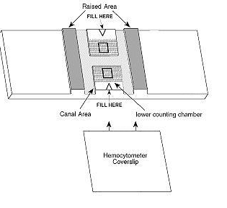
Figure 1: A drawing of the hemocytometer the arrows indicate the area that is filled with the counting solution and by capillary action the solution is drawn under the cover slip and covers the counting square. Taken and modified from:

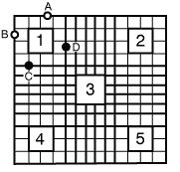
Figure 2: A drawing of the counting chamber. Squares 1-5 are included in the count only. Applying the rule that only cells touching the top and left boundaries of the squares are included in the count, cells A and B are included, whilst cells C and D are not.

Taken from

